**15 basic docker commands**

1. docker pull mysql

This command will pull the docker image from the docker hub

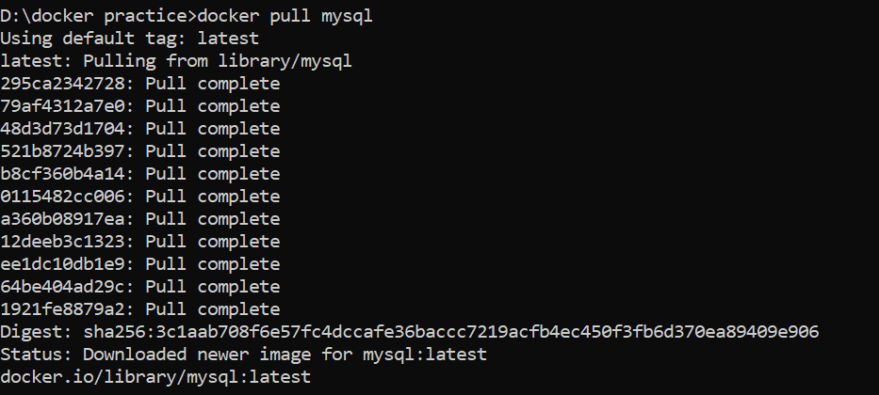

1. docker –version

It helps find the version of docker application we are using

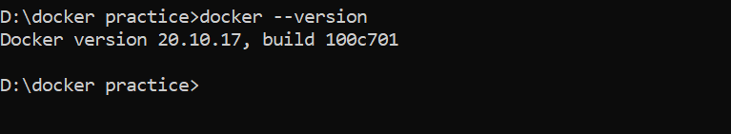

1. docker images

It list all the images we have pulled on our local machine along with version number, image id, memory size etc.,

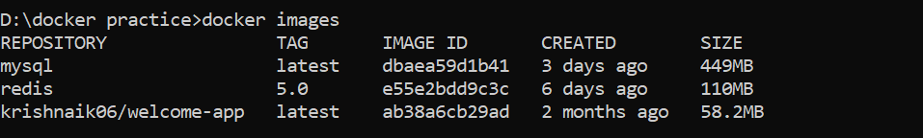

1. docker rmi <image_id>

This helps remove the docker images installed

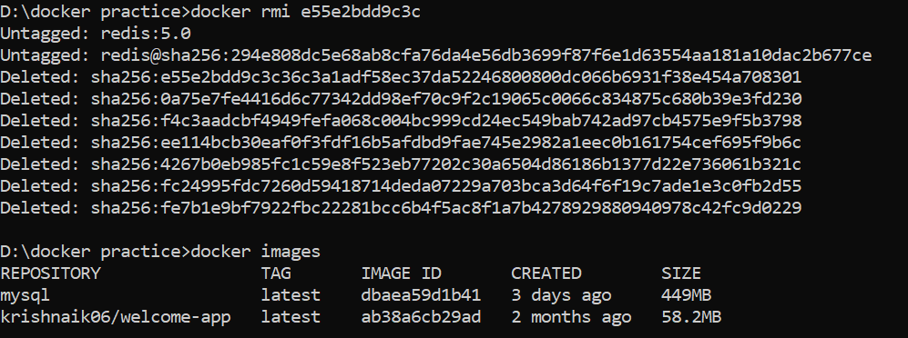

1. docker run

This will open the docker container of the docker image present in our local machine. ‘-d’ specifies the container to be opened in detached mode. Even if we have not downloaded the docker image, the run command will download the docker image and open the docker container

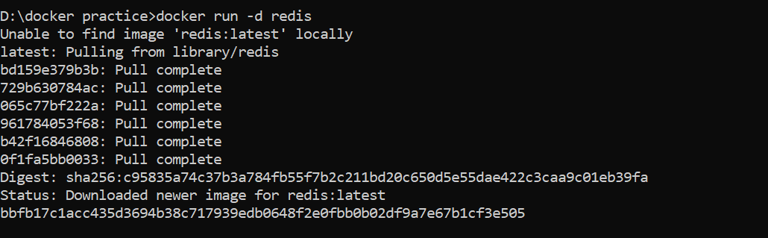

Using ‘-p’ specifies the port numbers of host machine and docker container



1. docker ps

List all the docker containers present in our local machine along with their container id. Using ‘-a’ will list even the containers that are not running



1. docker stop <container_id>

It stops the container from running

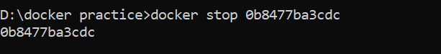



1. docker start <container_id>

It alternatively starts running the container

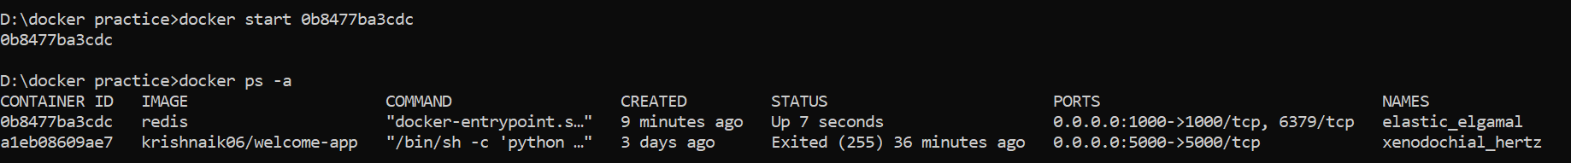

1. docker run <image>:<version-number>

If we specify the version number along with the docker image , we can download the specific version. If we do not specify the version , latest version will be downloaded

docker run --name <container_name>

adding ‘—name’ along with the run command while executing run command helps us give a name of our choice to the container

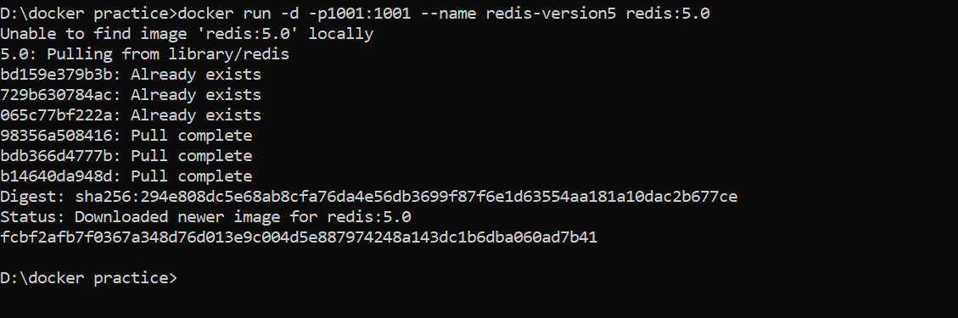



1. docker rm <container_id>

removes the docker container from our local machine. We need to stop the running docker container by using stop command before removing the container.

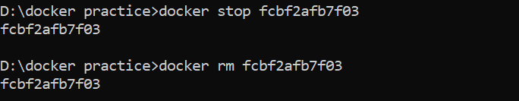

1. docker rmi <image_id>

removes the docker images downloaded in our host machine

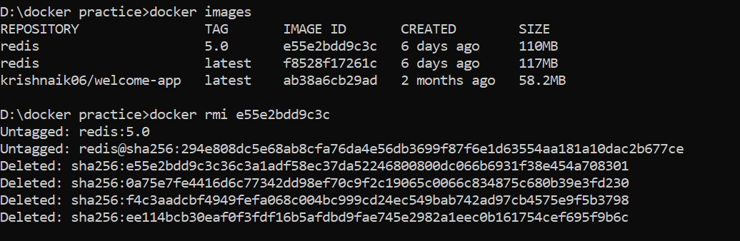

1. docker exec

it gets the terminal of the running container

‘-it’ specifies interactive terminal. It opens the virtual file system inside the container and helps navigate through different directories, check environment variables. This command is used in debugging operations

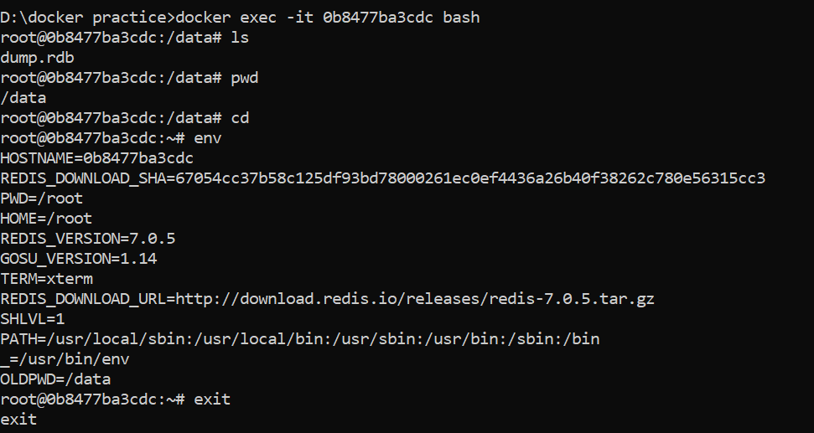

1. docker logs <container_name>:

It displays the information logged by the running container. It is used in debugging operations

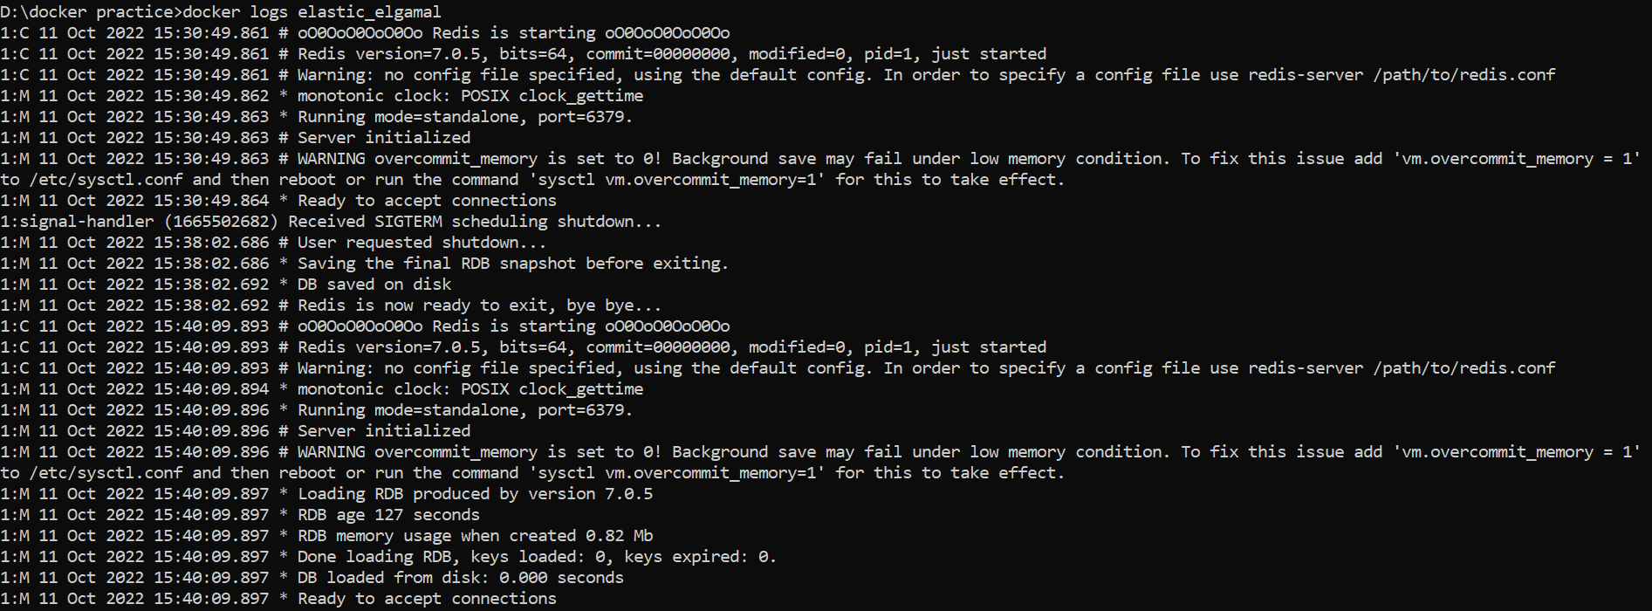

1. docker restart <container_id>

It restarts the docker container which has stopped running

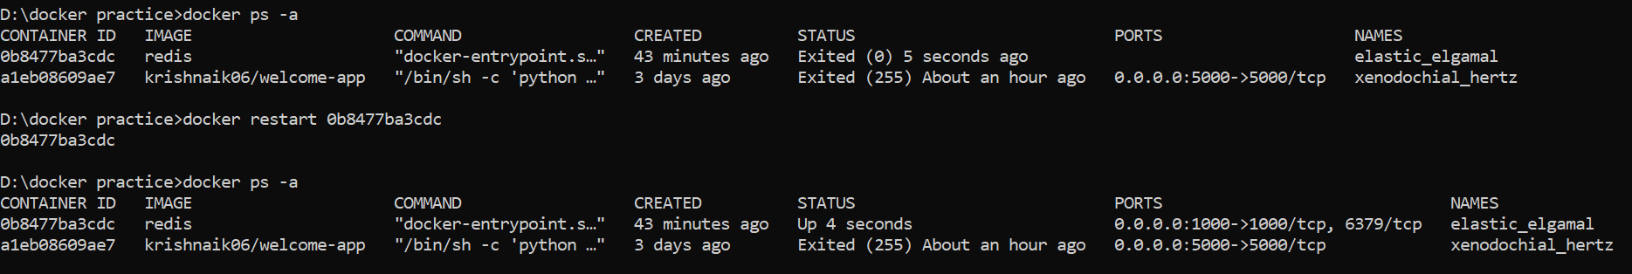

1. docker kill <container_id>

Kills the docker container immediately. Combination of stop and remove

